To find the distance between 2 points on a number line, count the number of hops from the first point to the second point.

The distance between A and B is 4.
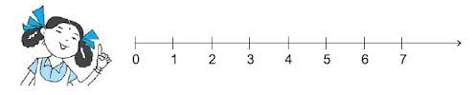
B
A

The distance between L and M is 1.
L
M

The distance between C and D is 3.
D
C

